User Manual of X8 Brushless ESC for Car

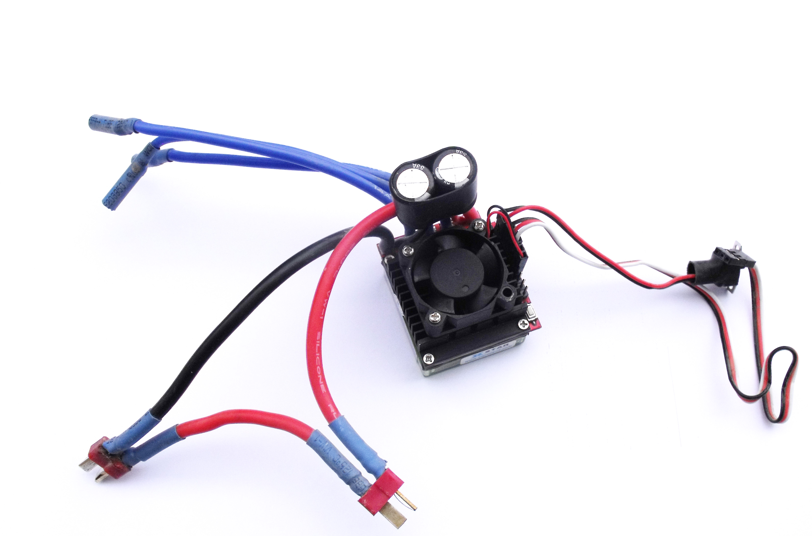

Features
- Full protection feature including low voltage, over-heat, throttle signal lost, startup protection and self-check.
- Compatible with sensorless brushless motor.
- Excellent startup performance, great throttle linear and quick throttle response.
- Support highest motor speed 240,000RPM (2 poles), 80,000RPM (6 poles) and 40,000 RPM (12 poles).
- The parameters of ESC can be configured via program card or the key on ESC.
- The low-voltage threshold and start-up power can be programmed quantified and precisely by program card.
- System can automatically detect throttle neutral point and neutral range is adjustable.
- Three work modes can match different requirement, 4 steps of maximum reverse force adjustment.
- 3 steps of maximum brake force adjustment, 5 steps of drag brake force adjustment, 4 steps of initial brake force adjustment.
- The X8 ESC have connector for light .User can assemble car light.(refer to the wiring diagram).
Specification
P/N | Continuous current | Battery Cell |  | Dimension (mm)  L×W×H | Weight（g） | BEC | Program  By  card | Program  By  key
P/N | Continuous current | Li-XX | Ni-H
X8 | 120A | 2-4 | 4-15 | 47x41x29 | 95 | 3A/5V(switch) | Yes | Yes
Using ESC
Normal Startup Procedure
Move throttle stick to the neutral position → Switch on the transmitter →Connect battery pack to ESC → System detects the neutral throttle signal, makes a long “beep-” sound → System detects battery voltage and makes several short “beep-” sounds, which denotes the number of battery cells → when self-test is finished → “♪ 1 2 3” tone should be emitted →ready for start.
Setting Throttle Range (Throttle range should be setup when a new transmitter is being used)
- “ SET ” KEY is used
Switch off the ESC → Switch on the transmitter → Press and hold the “ SET ” KEY → Switch on the ESC → Push the throttle stick to the top point of forward within two seconds → Wait for one second → System detects the Max throttle signal, and makes two “beep-” sounds, which denotes that Max throttle has been confirmed and saved → Pull the throttle stick to the top point of backward →System detects the Min throttle signal, makes two “beep-” sounds, which denotes that Min throttle has been confirmed and saved → Release the “ SET ” KEY → Setting is finished.

The LED Status
1, The green LED lights when the car go forward, the red LED lights when the car is backward, both the red and green LED light when the car is braking.
2, when the car stops, red LED and green LED don’t light.
3, both the red and green LED flash, when the voltage is low or over, or the ESC is over-heat.

Protection
A. Low voltage protection: When power voltage is lower than the cutoff threshold, ESC will cut off output power.
B. Throttle signal lose protection: The ESC will cut off the motor, if throttle signal lost for 0.5 second.
C. Overheat protection: output power will be reduce to cool down if temperature of the board of CPU gets to 100℃, and the output power will raise after temperature gets low.
D. Self-check: ESC will start self-test when power on, if self-test fail, ESC will continuously emit 20 short “beep-” tones.

Configurable Parameter with LED Program Card (Program Card not included)
1. Cut Off Voltage (Low voltage Protection threshold): User can set proper cutoff voltage according to cell quantity in range of 00.0-49.9V, the default is 00.0V。
Note: System will detect battery cells and calculate proper threshold automatically if this setting is 00.0V, protection threshold for each Li-XX cell is 2.8V. For example: if the battery pack is 3 cells Li-xx, cutoff voltage will be: 2.8V*3=8.4V.
2．Start Power Percent (Start Force): to set the Percent of output power when the car start in range of 00% - 29%, default is 00%. Under default setting, output power is decided automatically by system according to throttle stick position.
3．Advance Timing : low, middle ,high and highest. Default is middle. Low advance timing is recommended for high inductance and low KV motors. High advance timing is recommended for low inductance and high KV motors.
4．Run Mode: One, Two, Two2. Default is Two2.
One: the car can go forward only, and brake continuously if push the throttle stick to backward zone.
Two: Bi-directional mode, the car go forward when the throttle stick is located at the forward zone, when the throttle stick is located at the backward zone, the car will go backward, the brake will occur when direction change.
Two2: Conditional Bi-directional mode. the car go backward only when car is stop and throttle stick is pushed from neutral zone to backward zone. When car is running forward, push throttle stick to backward zone, car will keep brake until it stops, the throttle stick return the neutral zone, and push the throttle stick to the backward zone, then the car will go backward.
5．Brake Force: 50%, 75%, 100%. Default is 100%. The ESC provides proportional brake function. The brake force is related to the position of the throttle stick. It refers to the maximum brake force when the throttle stick is pushed to the top point of the backward zone.
6．Drag Brake Force: 0,5%,10%,15%,20%. Default is 0. When the throttle stick is located at the neutral zone, the ESC provides a slight brake force.
7．Neutral Range: 6%, 8%, 10%. Default is 8%. Within this zone, the motor will be turned off.
8．Initial Brake Force: 5%, 10%, 20%, 30%. Default is 5%. It refers to the brake force when the throttle stick is located at the initial position of the backward zone.
9．Reverse Force: 25%, 50%, 75%, 100%. Default is 25%. It refers to the maximum force when car run in reverse direction.

Programming the ESC with key

3.Set item value
After entering the item, you will hear several tones and green led flash in loop, Set the value matching to a tone by press the “SET” KEY within 2 second when you hear the tone, then you will hear special tone like“♪ 5 6 5 6”. It means the value is set and saved.
Hold the SET KEY for 3 second, you will go back to step 2. if release the SET KEY within 2 second, you will exit the program mode quickly.
Tone

Itemsbeeb-,1 tone
green led flash
1 short timesbeeb-beeb-,2 tone
green led flash
2 short timesbeeb-..,3 tone
green led flash
3 short timesbeeb-…,4 tone
green led flash
4 short timesbeeb-----,1 long tone green led flash 1 long timesbeeb-…..,N tone
green led flash
N times1. Brake Force50%75%100%2. Drag Brake05%10%15%20%3. Run ModeONETWOTWO24. Start Force10%15%20%23%25%5.Li-xx Cells NumberAuto detect2 cells3 cells4cells5 cellsN cells6.Cutoff threshold2.5V2.8V3.1V7. TimingLowMidHighHighest8.Neutral Range6％8％10％9.Initial Brake Force5％10％20％30％10.Reverse Force25％50％75％100％
1.Enter program mode
1、Turn off the ESC, Switch on transmitter, keep throttle stick to the neutral position
2、Press and hold the “SET” KEY, Switch on the ESC
3、Wait for 3 seconds, special tone like “♪ i3i3” should be emitted ,which means program mode is entered
2.Select programmable items
After entering program mode , hold the “SET” KEY continuously, you will hear 11 tones and red led flash in a loop in the following sequence. If you release the “SET” KEY within 2 seconds after one kind of tone, this item will be selected, and enter step 3
⑴“beeb-” (1 short tone, red led flash 1 short times) Brake Force
⑵“beeb- beeb-” (2 short tone, red led flash 2 short times) Drag Brake
⑶“beeb- beeb- beeb-” (3 short tone, red led flash 3 short times) Run Mode
⑷“beeb- beeb- beeb- beeb-” (4 short tone, red led flash 4 short times) Start Force
⑸“beeb----- ” (1 long tone, red led flash 1 long times) Li-xx cells
⑹“beeb----- beeb- ” (1 long 1 short tone, red led flash 1 long times and 1 short times) Cutoff threshold
⑺“beeb----- beeb- beeb-” (1long 2 short tone, red led flash 1 long times and 2 short times) Timing
⑻“beeb----- beeb- beeb- beeb-” (1 long 3 short tone, red led flash 1 long times and 3 short times) Neutral Range
⑼“beeb----- beeb- beeb- beeb- beeb-” (1 long 4 short tone, red led flash 1 long times and 4 short times) Initial Brake Force
(10)“beeb----- beeb-----” (2 long tone, red led flash 2 long times) Reverse Force
(11)“beeb----- beeb----- beeb-----” (3 long stone, red led flash 3 long times) Restore all to default and Exit
Note: 1 long “beeb-----” = 5 short “beeb-”, flash 1 long times=5 short times
4.Exit program
There are two ways to exit program mode:
1、 In step 2, after 3 long tone (The item #11)，please release the KEY within 2 seconds.
2、 In step 3,after special tone“♪ 5 6 5 6”, please release the KEY within 2 seconds.

Note: 1. 1 long “beeb-----” = 5 short “beeb-”. For example, in “Li-xx Cells Number” setting, 1 long “beeb-----” plus 1 short “beeb-” ( 5+1=6 ), means a 6 cells Li-xx battery pack..
2.The boldface in above form is the default value.
3. Low voltage Protection threshold (Cutoff voltage) = Li-xx Cells Number * Cutoff threshold. Cutoff threshold is Protection threshold for one cell Li-xx. For example: if Li-xx Cells Number is 3 and Cutoff threshold is 3.1V, the cutoff voltage will be: 3.1V*3=9.3V.
4. In step 2, after 3 long tone (The item #11)，if release the “SET” KEY within 2 seconds, you will exit program. But if you don’t change other item value, the ESC will restore all items to default value, and makes two “beep-” sounds.
Throttle Diagram

Wiring Diagram
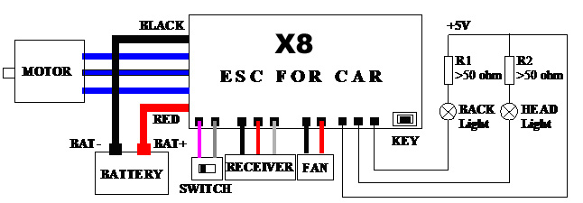

NOTE: 1. The resistance of R1 and R2 which limit to current should be greater than 50 ohm, it recommended for 100Ω, 1/2W resistance of the metal mold.
2. The BEC of X8 is Switch mode and can support 3A continuous current. In order to reduce the interference, it is necessary to keep ESC far away from the receiver and antenna.

